

|  |  |  |  |  |  |  |  |  |
| --- | --- | --- | --- | --- | --- | --- | --- | --- |
|  | | | | | | | | |
|  | | Project Report | | | | |  | |
|  |  | | | | | | |  |
|  | | | |  |  | | | |
|  | | | | Mariam SalimMeerab Khan |  | | | |
|  | | | | May 3rd, 2025—Programming Patterns (sect.2)420-301-VA—Salehi Dastjerdi, Niloufar |  | | | |
|  | | |  | | |  | | |

|  |  |  |  |  |  |  |
| --- | --- | --- | --- | --- | --- | --- |
|  |  | |  |  | |  |
|  | Hotel Management System | | | | |  |
|  |  |  | | |  |  |
|  |  |

|  |  |  |  |  |  |  |  |  |
| --- | --- | --- | --- | --- | --- | --- | --- | --- |
| Decorative | |  |  | | |  |  | |
|  | | Final Project’s Report | | | | |  | |
|  | |  |  | | |  |  | |
|  | Introduction The Hotel Management System is a small application that allows hotel staff (e.g.: receptionists) and guests to interact with the system from a graphical interface (GUI) and each have access to a separate window since they have different access levels. | | | | | | |  |
|  | Staff Window Features | | |  | Client Window Features | | |  |
|  | -Login button to sign in as a client  -View all or only current clients  -View all or only available rooms  -View all bookings  -Book a room for a client  -Check out a client  -Search for client  -Search for room  -Update room  -Add room  -Add client | | |  | -Login button to sign in as staff  -View available rooms  -Search rooms by room type  -Search by price range  -Book a room | | |  |

Program Features & Screenshots

##### Client Window Features

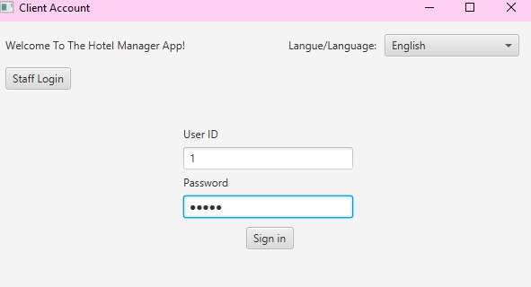

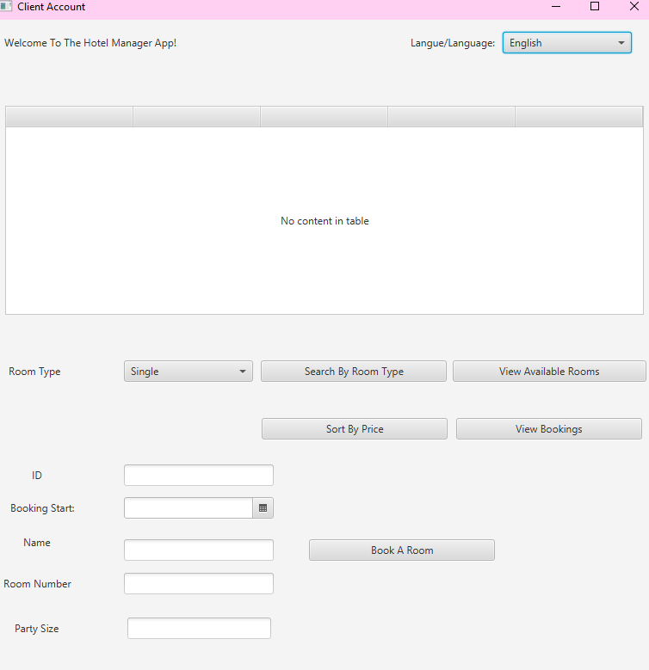

View available rooms

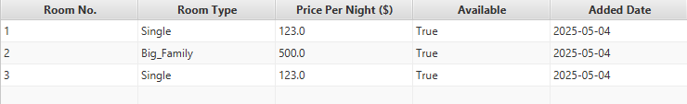

Search rooms by room type

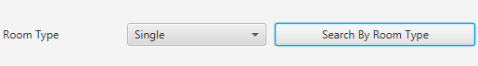

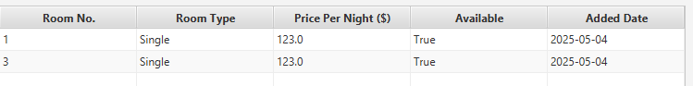If an invalid room type was entered

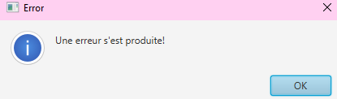

Sort by price low to high



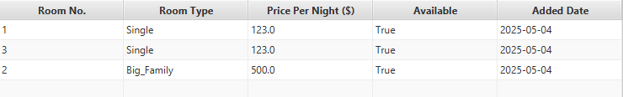

French language (switch while the app is running):

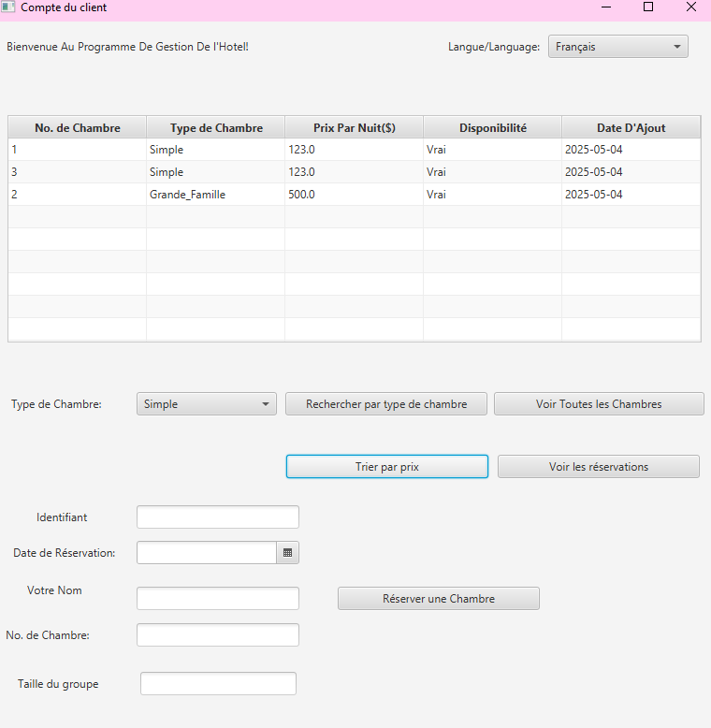

Staff window:

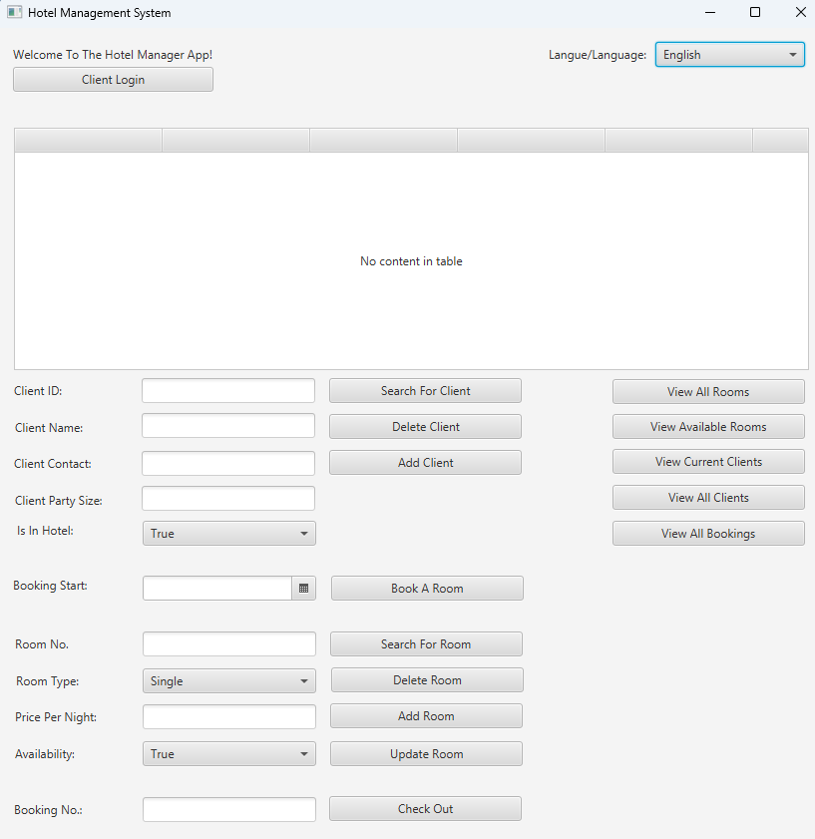

Add Room (another was added before):

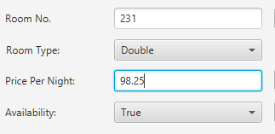

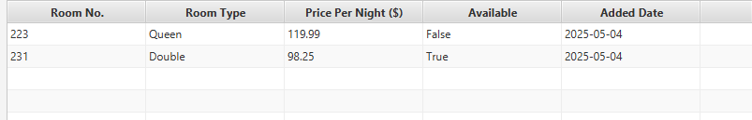

Add another client:

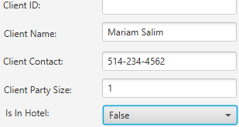

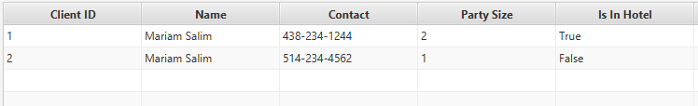

Search for a client:





Search for room:





Book a room:

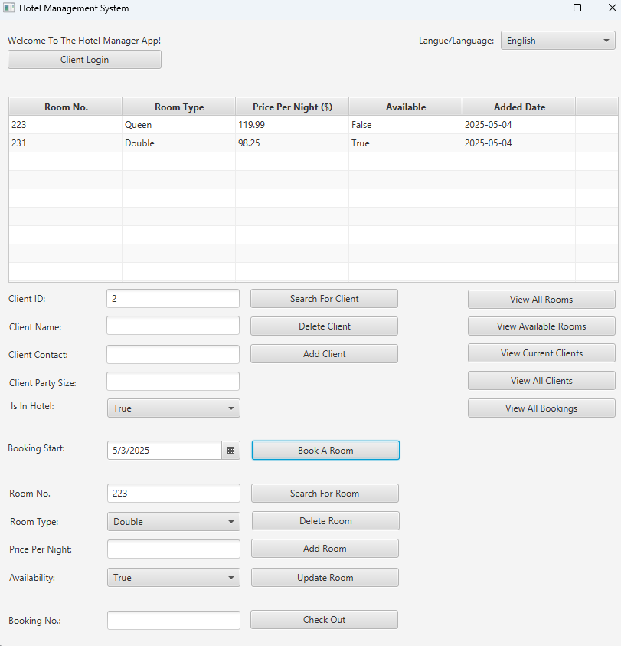

Cannot book unavailable room, it’s invalid.

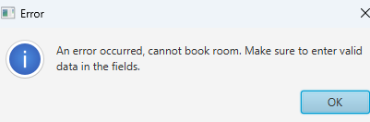

Change room No to 231, then book (another booking was there before):

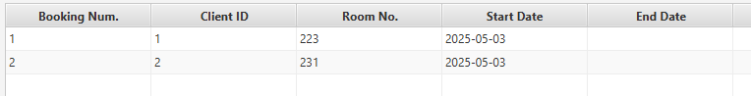

Check out:





See the updated Is In Hotel after operations (a client checked out and one came in):

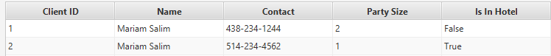

Trying to delete a booked room:

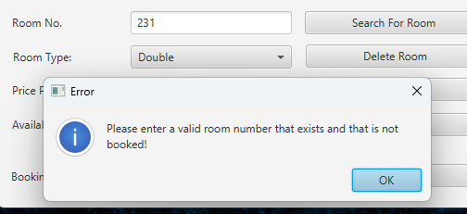

View current clients in hotel:

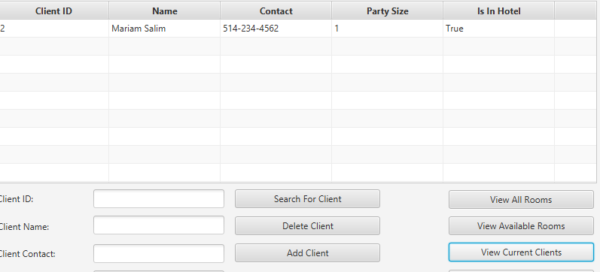

View all clients:

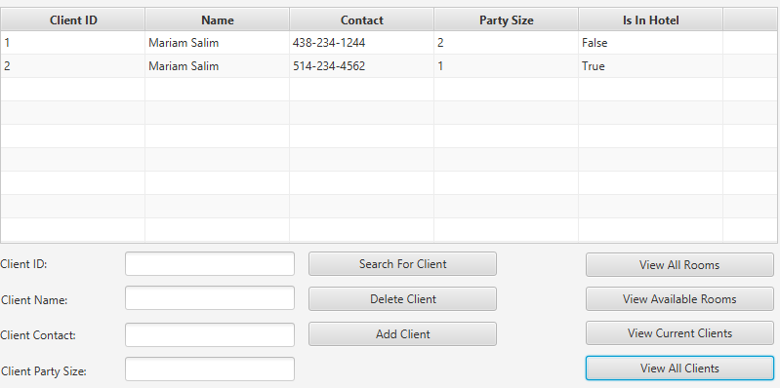

View all rooms:

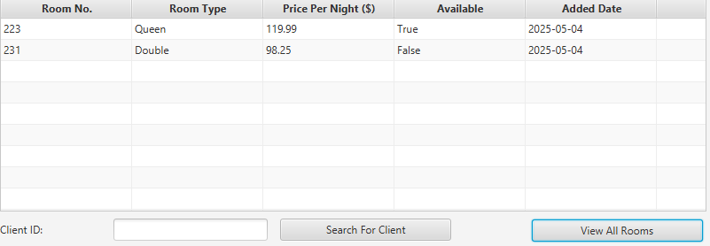

View available rooms:

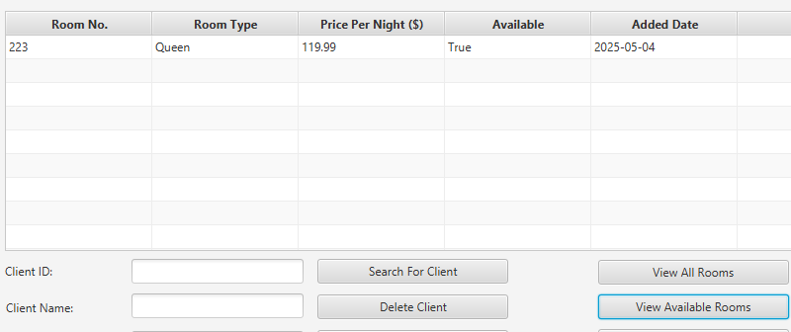

French language (switch while the app is running):

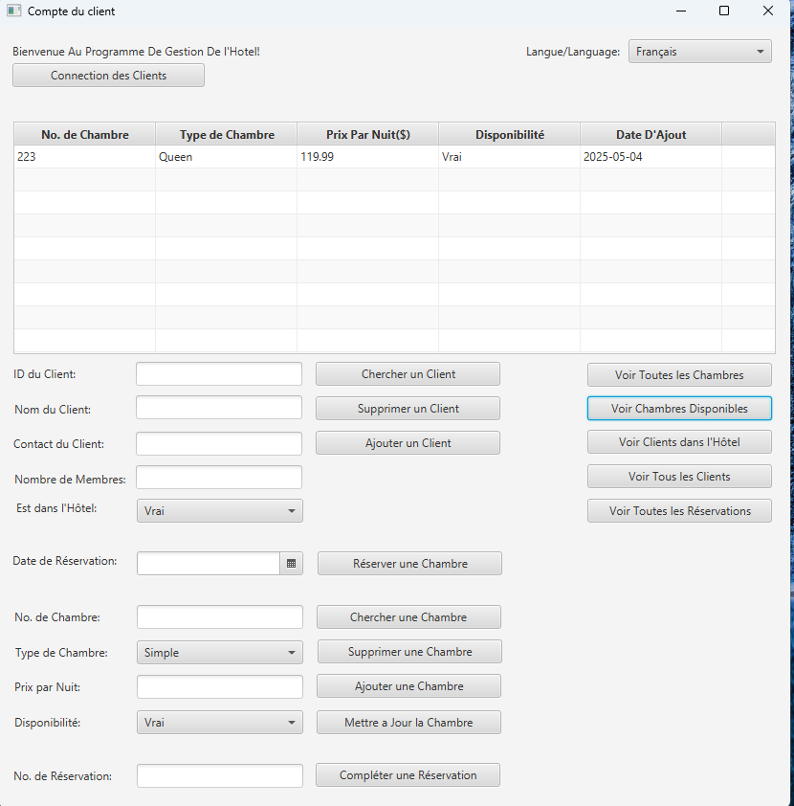

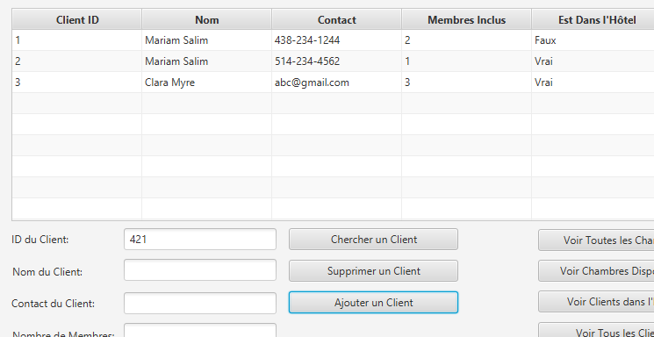

Cannot book queen room (2 people) for a party of 3:

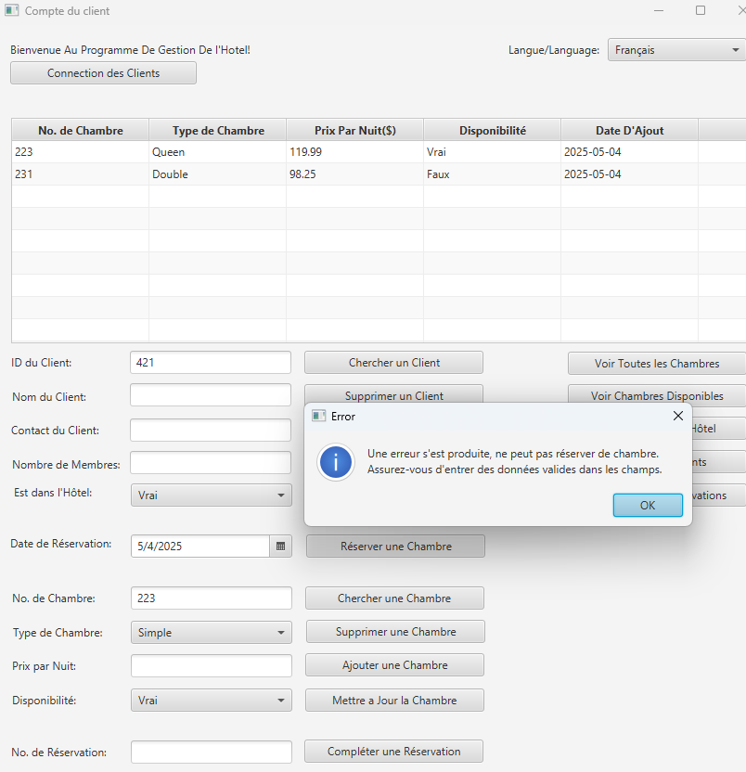

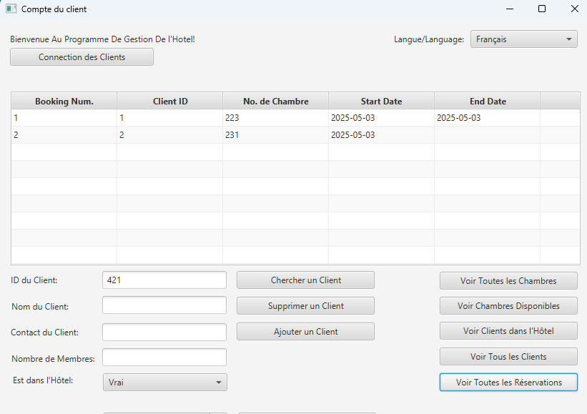

Challenges

We faced many challenges along the way. Making a jar file that connected with the database was an issue for us, but we managed to fix it. We also had some difficulties using GitHub to merge our work, since it was our first time needing to do this. Of course, coding the whole project and learning new things along the way was also a challenge, since we have many other assignments, finals and projects at the same time. Also, since we did not completely understand how to start from the beginning, we made a first version of the project that was inefficient for a database, so we restarted. Similarly, there were things that we understood along the way that required us to change many things in our project, such as the language translation. However, all in all, this project was an excellent learning experience!

Learning Outcomes

We got to learn many concepts related to JavaFX, including its different types of controls and layouts. The different database methods using java. The interaction with I18N Java classes, Resource Bundle and Locale classes. The most important things we learned is translation, GUI with javaFX and connection to the database. Now, we can make important projects with this knowledge.

|  |  |  |
| --- | --- | --- |
|  |  |  |

|  |  |  |  |
| --- | --- | --- | --- |
|  |  |  |  |